

Department of Computer Science and Engineering

Summer-2022

Course Code: CSE405

Course Title: Computer Networks

Section: 1

Project Report on

**Designing a full-fledged network for an organization with multiple subnets.**

**Submitted by:**

Name: Abdullah al Tamim

ID: 2020-1-60-127

**Instructor:**

Dr. Anisur Rahman

Associate Professor

Department of Computer Science and Engineering

East West University

**Preface:**

Completing the project helped us to know more about building full fledged computer networks. We can implement this knowledge to configure networks in real life and also to maintain computer networks.

**Description:**

University of Professionals, is an enterprise like East West University, owns a large number of computers, with a complex network infrastructure. Apart from wired internet access to all the classrooms, labs, employee PCs, library and other administrative and academic wings, the university also provides wireless internet access for everyone. On top of that the university runs a number of complex networked systems to support several of its business process like admissions, advising, results, eTender, library management, accounts and so on. This complex network infrastructure is subnetted and switching/routing mechanisms are in Practice.

**Objective:**

Our goal is to design a complete model of a complex network by discovering the interconnectivity of the systems and subnetworks, which will reflect the University’s structure and facilities, features within the network will include the followings:

* DNS sever will be installed to locate webserver - meaning people will browse
* University’s web site with the following address: http://www.professionals.edu
* Configure the whole network in such a way that IP for the hosts of different campuses will be automatically assigned by a single DHCP server.
* Among the hosts make sure wireless links to the networks are available.
* University’s full network has covered its six campuses with six routers;
* Connectivity between all the hosts will be established.

**Requirements:**

* 6 (PT-Router)
* 6 (Switch-2960)
* DHCP Server (Dynamic Host Configuration Protocol)
* DNS Server (Domain name System)
* WEB Server
* Straight Through Cable to connect router with switch and devices
* Serial DCE Cable to connect a router with another router
* PC
* Laptop
* Smart Phone
* Access-Point (WIFI zone)

**Diagram:**

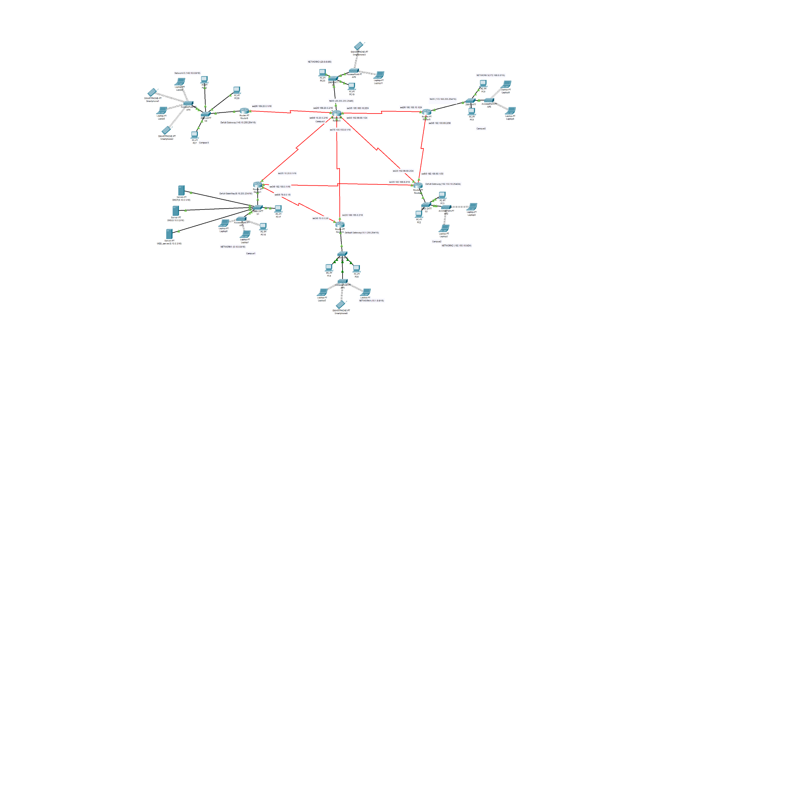

**Design Issues:**

Here, in total 14 networks were considered. Each of the networks has some wired as well as wireless hosts. Here only 1 DHCP server is used to distribute ip addresses among the devices. Network address from all 3 classes were given. Also, the design incorporated different subnets.

Design specifications for each campus is given below in details:

**Campus 1:**

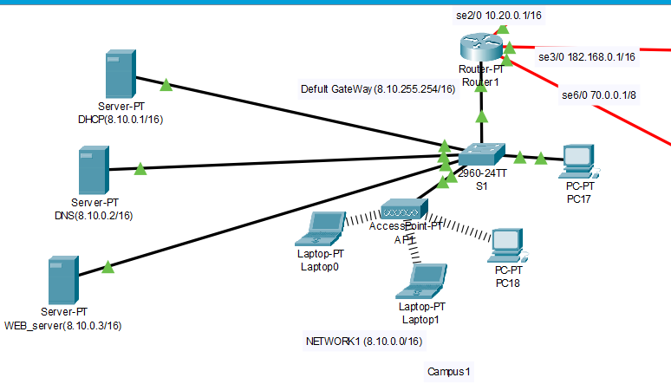

interface fa0/0

ip address 8.10.255.254 255.255.0.0

no shut

do wr

exit

interface se2/0

ip address 10.20.0.1 255.255.0.0

no shut

do wr

exit

interface se3/0

ip address 182.168.0.1 255.255.0.0

clock rate 64000

no shut

do wr

exit

interface se6/0

ip address 70.0.0.1 255.0.0.0

no shut

do wr

exit

**To Generate IP address from DHCP server**

interface fa0/0 ip helper-address 8.10.0.1do wr

exit

router OSPF 1

network 10.20.0.0 0.0.255.255 area 1 network 8.10.0.0 0.0.255.255 area 1 network 182.168.0.0 0.0.255.255 area 1

network 70.0.0.0 0.255.255.255 area 1

exit

**Campus 2:**

interface fa0/0

ip address 192.150.10.254 255.255.255.0

no shut

do wr

exit

interface se2/0

ip address 192.90.0.1 255.255.255.0

no shut

do wr

exit

interface se3/0

ip address 182.168.0.2 255.255.0.0

clock rate 64000

no shut

do wr

exit

interface se6/0

ip address 192.100.60.1 255.0.0.0

no shut

do wr

exit

**To Generate IP address from DHCP server**

interface fa0/0

ip helper-address 8.10.0.1

do wr

exit

router OSPF 1

network 182.168.0.0 0.0.255.255 area 1

network 8.10.0.0 0.0.255.255 area 1

network 182.168.0.0 0.0.255.255 area 1

network 70.0.0.0 0.255.255.255 area 1

exit

**Campus 3:**

interface fa0/0

ip address 20.255.255.254 255.0.0.0

no shut

do wr

exit

interface se2/0

ip address 169.20.0.2 255.255.0.0

no shut

do wr

exit

interface se3/0

ip address 195.168.0.1 255.255.255.0

clock rate 64000

no shut

do wr

exit

interface se6/0

ip address 10.20.0.2 255.0.0.0

no shut

do wr

exit  
interface se2/0

ip address 10.20.0.1 255.255.0.0

no shut

do wr

exit

interface se3/0

ip address 182.168.0.1 255.255.0.0

clock rate 64000

no shut

do wr

**To Generate IP address from DHCP server**

interface fa0/0 ip helper-address 8.10.0.1do wr

exit

router OSPF 1

network 10.20.0.0 0.0.255.255 area 1 network 8.10.0.0 0.0.255.255 area 1 network 182.168.0.0 0.0.255.255 area 1

network 70.0.0.0 0.255.255.255 area 1

exit

**Campus 4:**

interface fa0/0

ip address 20.255.255.254 255.0.0.0

no shut

do wr

exit

interface se2/0

ip address 169.20.0.2 255.255.0.0

no shut

do wr

exit

interface se3/0

ip address 195.168.0.1 255.255.255.0

clock rate 64000

no shut

do wr

exit

interface se6/0

ip address 10.20.0.2 255.0.0.0

no shut

do wr

exit  
interface se2/0

ip address 10.20.0.1 255.255.0.0

no shut

do wr

exit

interface se3/0

ip address 182.168.0.1 255.255.0.0

clock rate 64000

no shut

do wr

**To Generate IP address from DHCP server**

interface fa0/0 ip helper-address 8.10.0.1do wr

exit

router OSPF 1

network 10.20.0.0 0.0.255.255 area 1 network 8.10.0.0 0.0.255.255 area 1 network 182.168.0.0 0.0.255.255 area 1

network 70.0.0.0 0.255.255.255 area 1

exit

**Campus 5:**

interface fa0/0

ip address 20.255.255.254 255.0.0.0

no shut

do wr

exit

interface se2/0

ip address 169.20.0.2 255.255.0.0

no shut

do wr

exit

interface se3/0

ip address 195.168.0.1 255.255.255.0

clock rate 64000

no shut

do wr

exit

interface se6/0

ip address 10.20.0.2 255.0.0.0

no shut

do wr

exit  
interface se2/0

ip address 10.20.0.1 255.255.0.0

no shut

do wr

exit

interface se3/0

ip address 182.168.0.1 255.255.0.0

clock rate 64000

no shut

do wr

**To Generate IP address from DHCP server**

interface fa0/0 ip helper-address 8.10.0.1do wr

exit

router OSPF 1

network 10.20.0.0 0.0.255.255 area 1 network 8.10.0.0 0.0.255.255 area 1 network 182.168.0.0 0.0.255.255 area 1

network 70.0.0.0 0.255.255.255 area 1

exit

**Campus 6:**

interface fa0/0

ip address 20.255.255.254 255.0.0.0

no shut

do wr

exit

interface se2/0

ip address 169.20.0.2 255.255.0.0

no shut

do wr

exit

interface se3/0

ip address 195.168.0.1 255.255.255.0

clock rate 64000

no shut

do wr

exit

interface se6/0

ip address 10.20.0.2 255.0.0.0

no shut

do wr

exit  
interface se2/0

ip address 10.20.0.1 255.255.0.0

no shut

do wr

exit

interface se3/0

ip address 182.168.0.1 255.255.0.0

clock rate 64000

no shut

do wr

**To Generate IP address from DHCP server**

interface fa0/0 ip helper-address 8.10.0.1do wr

exit

router OSPF 1

network 10.20.0.0 0.0.255.255 area 1 network 8.10.0.0 0.0.255.255 area 1 network 182.168.0.0 0.0.255.255 area 1

network 70.0.0.0 0.255.255.255 area 1

exit

**Server configuration:**

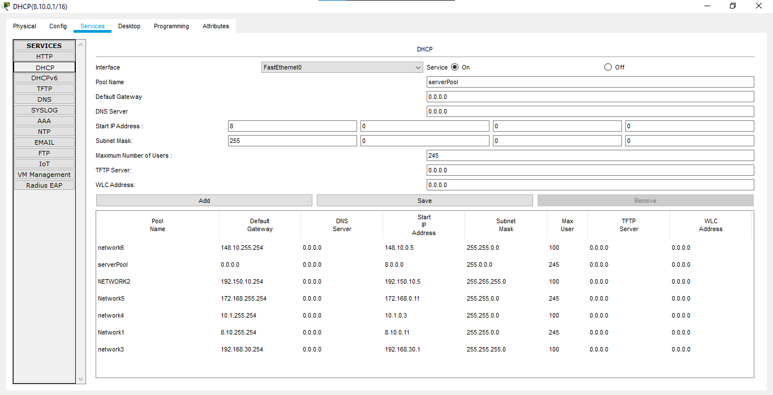

Fig: Server pools for all 6 networks in DHCP server.

Fig: IP address generated from DHCP server.

Fig: Website of the university

**Conclusion:**

In summary, a network is two or more computers connected by a telecommunication system to communicate and share resources. Without a network, university could not share resources more effectively and increase productivity. The LAN network enables the university to use the Internet in large areas. This feature enabled the university to exchange data over the network. As networks have many benefits to every user, whether our network is wired or wireless. Networks are an important part of technology.

In this project, I have learned so many new things to implement a network for this university and so many new features of the CISCO Packet Tracer. In future, it will help me to design a broad networking system.